STAT 145 Final Exam Review All interpretations MUST be in the context of the problem.

Part II Practice When statistical technology can be used, it should be used.

The following data can be found in the Week 12 STAT 145 Data File under sheet: **Infant Mortality**

1. Infant mortality rate is concerned with infant deaths during the first year of life. Generally, the infant mortality rate provides the number of deaths per 1000 live births. A study listed the 24 developed nations by their infant mortality rate. The table below provides the results:

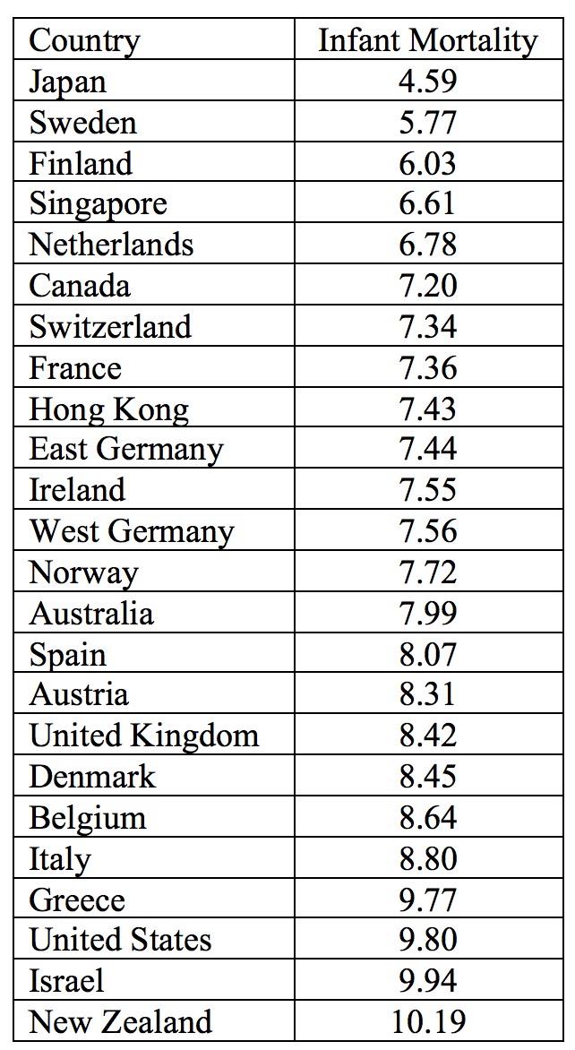

A. Construct a boxplot showing any outliers for the infant mortality rates.

B. In the boxplot of this data, any mortality rates below _____ OR above _____ would be considered outliers. Fill in the blank; SHOW YOUR WORK as you calculate the outlier fences.

The following data can be found in the Week 12 STAT 145 Data File under sheet: Computer Sales

There are two sheets---one is unstacked data and one is stacked computer sales data.

1. The number of computers Carl sold at his computer store job each month last year:

51, 17, 25, 39, 7, 49, 62, 41, 20, 6, 43, 13

The number of computers Angela sold at her computer store job each month last year:

34, 47, 1, 15, 57, 24, 20, 11, 19, 50, 28, 37

1. Build comparative boxplots. Find the mean value for each person.
2. Compare the box plots (compare shape, center and spread)
3. The manufacturer of *Drive On Us* tires states that, “The lifetimes of our tires follow a bell-shaped distribution with mean 50,000 miles and standard deviation 6,000 miles”.

A. Draw a picture of the empirical rule intervals for the lifetimes. Include a number line with values, and label the percentages.

B. What percentage of tires from *Drive On Us* last between 38000 and 62000 miles?

C. What percentage of tires from *Drive On Us* last less than 44000 miles?

D. 16% of all *Drive On Us* tires last longer than ____________ miles.

E. Daisy bought a *Drive On Us* tire for her car. This tire had a lifetime of 36780 miles. Would you consider this lifetime to be unusually low? EXPLAIN.

The following data can be found in the Week 12 STAT 145 Data File under sheet: Fish Length

1. Researchers are studying the growth of a species of fish. The fish are placed in a tank immediately after birth. At regular intervals, a fish is chosen at random and its length measured.

|  |  |
| --- | --- |
| **X = Age (days)** | **Y = Length (um)** |
| 14 | 590 |
| 28 | 1305 |
| 41 | 1915 |
| 55 | 2140 |
| 69 | 3920 |
| 83 | 3535 |
| 97 | 3030 |
| 111 | 4465 |
| 125 | 4530 |
| 139 | 3257 |
| 153 | 4566 |

1. Construct a scatterplot. Compute and interpret the correlation value.
2. Provide the equation of the regression line for this data.
3. Write a sentence to interpret the slope of your regression line.
4. Compute and interpret R2.

E. What length would you predict for a fish who is 50 days old? SHOW YOUR WORK and clearly state your answer.

The following data can be found in the Week 12 STAT 145 Data File under sheet: Calories

1. People like to eat chocolate chip cookies, and love to believe that there aren’t that many calories in each serving. A researcher at Consumer Reports would like to convince consumers that there are, in fact, more than 150 calories in a serving of chocolate chip cookies. She randomly selected both fresh-baked (from a boxed cookie mix such as Duncan Hines and Pillsbury) and packaged (such as Pepperidge Farm and Nabisco) cookies to obtain the following calorie information.

|  |  |  |  |  |  |  |  |
| --- | --- | --- | --- | --- | --- | --- | --- |
| 158 | 157 | 151 | 143 | 135 | 151 | 154 | 143 |
| 173 | 152 | 145 | 161 | 160 | 168 | 158 |  |

1. Does the researcher’s sample provide sufficient evidence to support the idea that the mean calories in a serving of chocolate chip cookies is greater than 150? Show the complete testing process.
2. There is a small chance that your decision was incorrect. If so, what type of error would this be? EXPLAIN.
3. Red/green color blindness causes problems in distinguishing reds and greens. Many studies have been conducted with Caucasian males, among whom 8% have red-green color blindness. However, there is limited information on this phenomenon among other ethnicities. A researcher in China believes the percentage of red-green color for Asian males is different than the 8% for Caucasians. She conducts a study on 200 randomly selected Asian men, and finds that 9 have red-green color blindness.
4. Does the Chinese researcher’s sample provide sufficient evidence to support the idea that the proportion of red-green color blindness among Asians is different from 8%? Show the complete testing process.
5. There is a small chance that your decision was incorrect. If so, what type of error would this be? EXPLAIN.
6. Researchers surveyed a random sample of Americans asking whether or not they had student loan debt in excess of $25,000. The 95% CI for the proportion of all Americans with student load debt in excess of $25,000 is ( .21, .39 ).
7. Write a concluding sentence for the confidence interval result.
8. The U.S. Department of Education recently stated that “Thirty percent of Americans have student loan debt that is greater than $25K”. Based on the given confidence interval, is this statement reasonable? EXPLAIN.
9. Based on the given confidence interval, can you be 95% confident that the percentage of Americans with student loan debt in excess of $25,000 is less than 25%? EXPLAIN.
10. Determine the values for the point estimate and the margin of error.

The following data can be found in the Week 12 STAT 145 Data File under sheet: Shelf Life

1. The shelf life of packaged food depends on many factors. Dry cereal is considered to be a moisture sensitive product (no one likes soggy cereal!), with the shelf life primarily determined by moisture content. A study of one particular brand of cereal examined Time on Shelf (days) and Moisture Content (%). The data can be found in the Week 12 Data File under: Shelf Life.



A. Which of the following is the definition of correlation? Choose one.

1. Measure of the cause-and-effect relationship between X and Y
2. Strength of the relationship between any two variables
3. Strength and direction of the linear relationship between two numerical variables
4. Measure of the indirect relationship between two categorical variables

B. What is the value of the correlation for this data? _________________

C. Compute the least squares regression line for Moisture Content and Time on Shelf.

D. Write a sentence to interpret the slope of the line from part C (use variable names and units)

E. Write a sentence to interpret the coefficient of determination (R2)

F.  A line with a “good” fit has a value of R2 close to _____. EXPLAIN. 

1. A medical researcher is interested in finding out whether a new medication will have any undesirable side effects. The researcher is particularly concerned with the pulse rate of the patients who take the medication. A random sample of 41 patients results in mean pulse rate of 84.2, and a standard deviation s = 1.3.
2. Build and interpret a 95% confidence interval for the mean pulse rate. Show the statistical output and interpret in the context of the problem.
3. Once completed, determine if it is reasonable to say that the mean pulse rate is 82 beats per minute. Explain your answer.